Lesson Title: Humans-caused changes to the Ocean / acidification and sea level rise.

Course title and grade level: 9th grade Earth and Environmental Science.

Length of time: 2 class periods (block scheduling 1 hour 15 minutes per class)

**Core standards addressed with this lesson:**

**7.4.9.A:**

Compare and contrast the effect of the physical systems on people across **regions** of the United States.

**7.4.9.B:**

Compare and contrast the effect of people on the physical region across **regions** of the United States.

**7.4.12.A:** Analyze the global effects of changes in the physical systems.

**7.4.12.B:** Analyze the global effects of human activity on the physical systems.

**S11.D.1.3.3:** Explain factors (e.g., nutrient loading, turbidity, rate of flow, rate of deposition, biological diversity) that affect water quality and flow through a water system.

**4.8.10.C.** Analyze how human activities may cause changes in an ecosystem.

* Analyze and evaluate changes in the environment that are the result of human activities.

* Compare and contrast the environmental effects of different industrial strategies (e.g., energy generation, transportation, logging, mining, agriculture).

**Core objectives:**

By the end of this lesson, I expect students to be able to better understand the cause and effect of sea-level rise and the cause and effect of acidification in the oceans.

Class Day 1

(Intro 15-20 minutes)

Bell Ringer: What is the approximate elevation, above sea level, of our school?

Answer: About 450 feet above sea level. (about 140 meters)

We measure topography and elevation in relation to the average level of the Sea.

Historical information:

Massive ice sheets covered parts of North America, northern Europe, and several other regions during the last ice age. This huge volume of ice lowered global sea level by around 120 meters as compared to today.

Discuss the under-water river valley in the Chesapeake, when sea level was 120 meter slower, the Susquehanna flowed farther south forming a valley seen below:

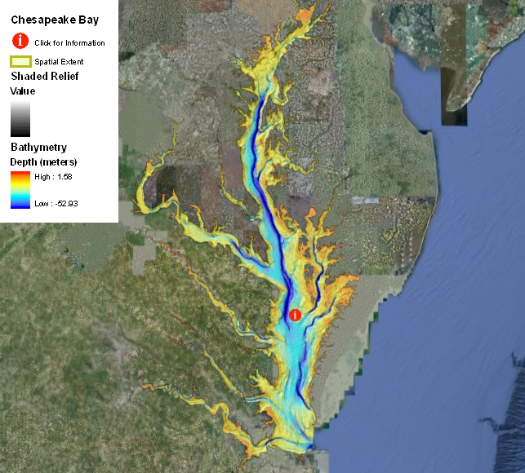

Current information:

As we have already learned this year, greenhouse gases like CO2 are trapping more and more solar energy causing the climate to warm. Ocean warming (thermal expansion) and the melting of mountain glaciers has contributed to an increase in sea level of about 1.7-1.8 mm/yr. Many scientists expect an increase in sea level around 1 meter in the next century.

Show simulation, focus especially on the 1 meter threshold:

<https://www.cresis.ku.edu/research/data/sea_level_rise/index.html>

Lab activity (separate document attached):

In this lab activity you will use Google Earth to make a new map of the Annapolis peninsula in Maryland *(*Broadneck Peninsula)*.* Assume the Ocean rises 1 meter by 2100.

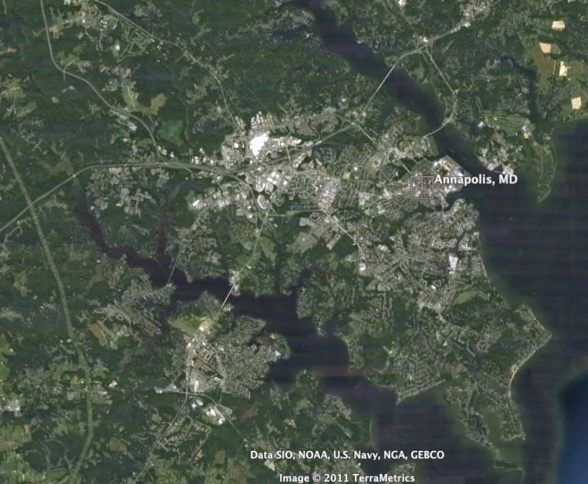

Teacher will demonstrate how to use google earth to find location, and map boundary.

Students now use macbooks to complete lab “Sea Level Rise Historical and Projected”. When done, they are to get lab checked and signed by teacher. Allow 15-25 minutes for lab.

Answer key:

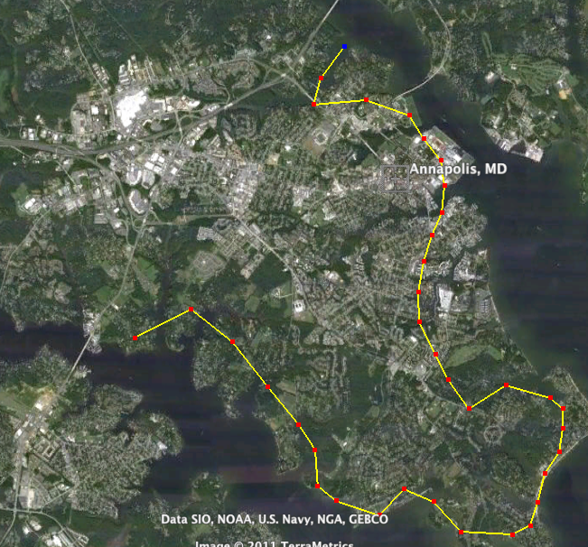

other example: Hilton Head Island, SC

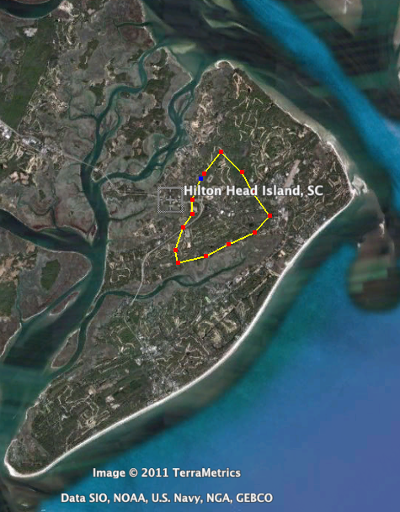

Discussion (15-20 minutes)

When done with lab, discuss the following with class:

1. What are people to do who currently live, go to school, own businesses in areas expect to be Ocean by 2100?
2. Could we just build a wall around these areas? (Discuss New Orleans)
3. What are some economic challenges this may cause for both the local and the national economy?
4. Will this be Worldwide? If so, what are some of the social, political, and economic challenges we will face in the future?
5. Can this be stopped? Slowed Down? Lessened?
6. What are some things you can do in your lifetime to reduce CO2 emissions?

Exit Bell Ringer:

According to most scientists, about how much of an increase in sea level will happen by 2100?

Answer: 1 meter